Exploratory data analysis of securities for supporting short-term investment decisions
Introduction
The aim of this project is to gain insights from historical stock-market data which can help short-term investors.
Objectives:
- Analyse strategies for short-term investment
- Identify key datasets for the relevant stock-market data
- Prepare data for analysis
- Develop a data pipeline, and process data
- Summarize insights

Strategy for short-term investment
Short-term investments are financial investments that can easily be converted to cash, typically within five years.¹ I used an article from Forbes² to select 3 stocks for analyzation, and added two I’m just curious about:
- Eli Lilly (LLY)
- ServiceNow (NOW)
- Shopify (SHOP)
- Riot Platforms Inc. (RIOT)
- Meta Platforms, Inc. (META)

Gather data
I use yfinance³ to access data on Yahoo Finance, and I registered to Quandl⁴ with my student e-mail.
Ethical considerations
I use yfinance to access data which uses Yahoo’s publicly available APIs.⁴
I registered to Quandl to get a personal API key for educational purposes.

Possible improvements
I may add a web-scraper to the pipeline which analyses articles of well-known websites that suggest financial assets for short-term investments.
I’m only using stocks now, but it can be expanded with other types of securities like bonds, ETFs, etc.
Different short-term strategies can be explored and built into the code.
Use another data source to validate data downloaded.

Final checklist:

¹: https://www.investopedia.com/terms/s/shorterminvestments.asp
²: https://www.forbes.com/sites/investor-hub/article/best-growth-stocks/
³: https://pypi.org/project/yfinance/
⁴: Disclaimer on yfinance’s site at the time of data gathering for this paper:
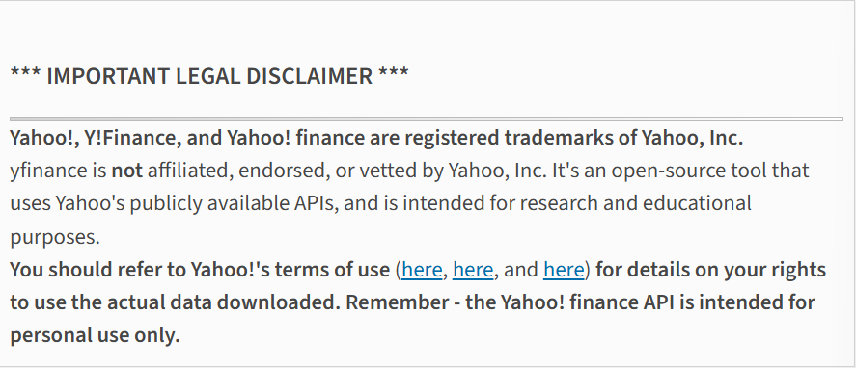
⁵: https://data.nasdaq.com/institutional-investors

